Data Flow Diagrams & Userstories

| Date: | 27-06-2025 |
| --- | --- |
| Team ID: | LTVIP2025TMID58018 |
| Project Name: | Freelance Finder |
| Maximum Marks: | 4 Marks |

# Data Flow Diagrams

A Data Flow Diagram (DFD) illustrates how data moves within the Freelance Finder platform. It shows interactions between system users (freelancers and clients), highlights data flow through various modules, and indicates storage points.

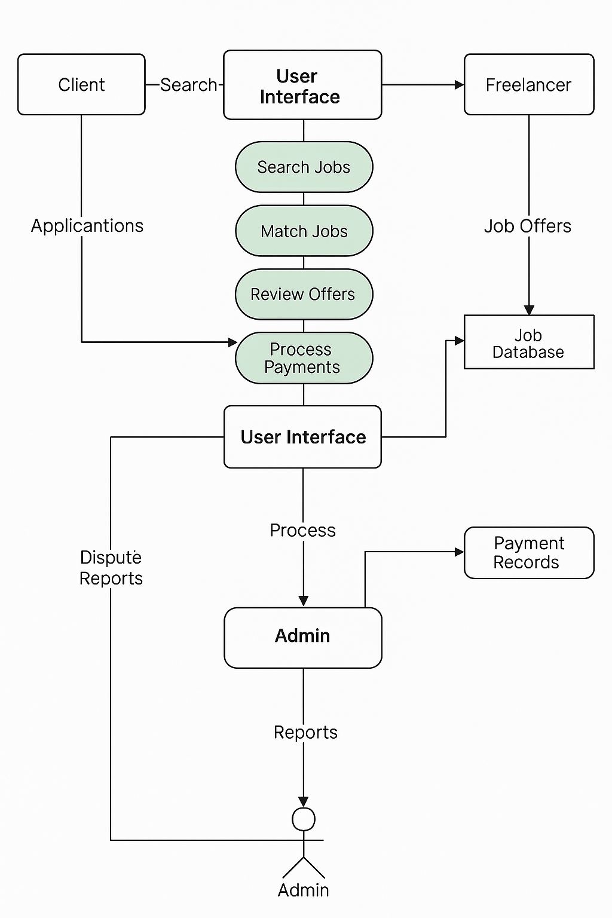

# User Stories

User story Table-Freelance finder

| Client | Review & Rating | As a client, I can review and rate the freelancer after project delivery. | Rating appears on freelancer’s profile. | Medium | Sprint-2 |
| --- | --- | --- | --- | --- | --- |
| Admin | User Moderation | As an admin, I can suspend or ban users violating terms. | Actions are recorded and visible in logs. | High | Sprint-1 |
| Client | Payment Processing | As a client, I can securely pay for completed projects. | Payment receipt is generated and stored. | High | Sprint-2 |
| Freelancer | Payment History | As a freelancer, I can view received payments. | Transaction history is accurate and up to date. | Medium | Sprint-2 |
| Admin | Profile Management | As an admin, I can update platform settings and user privileges. | Changes saved and reflected immediately. | High | Sprint-2 |